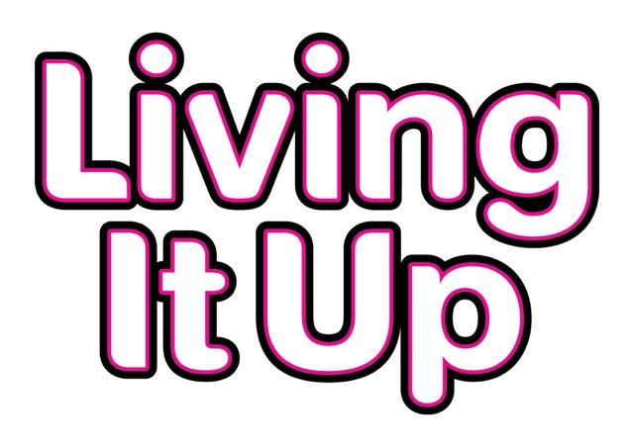
MEMBERSHIP FORM
Name:
Address:
Phone number:
Email address:
How would you like us to contact you? POST or EMAIL
Date of birth:
What is your gender?
Do you have a disability? YES or NO
If yes, what sort of disability do you have?

Will you bring your own supporter to any events? YES or NO
Are there any medical issues we need to know about? YES or NO
If yes, please let us know what these are below:

PLEASE TURN OVER - MORE QUESTIONS ON THE OTHER SIDE

Do you have any medical needs? YES or NO

If yes, what are your medical needs and how can we support you with this in case of an emergency?

Are there any other issues we need to know about? YES or NO
Please let us know what these are below:

Please give us a phone number for a person we can contact in case of an emergency:

Are you interested in us holding monthly events? YES or NO
If yes, what sort of things would you be interested in? (please circle)
Karaoke, Learning to DJ, Meals out, Quiz nights, Dance classes, Speed dating, Barn dances, Live bands

Would you be interested in joining a service user committee to discuss Living It Up events? YES or NO
Would you be interested in us telling you about any new projects that we start? YES or NO
Can we use any photos we take of you on our social media, website and for marketing materials? YES or NO

By filling in this form, you are agreeing that we can hold your information on our computer system and contact you about the things that you are interested in.
Do you understand? YES or NO

